TITLE OF THE PROJECT

TO DESIGN SPRING DAMPING SYSTEM

NAME: - Abhik Patra

Roll No.:2305588

SECTION: K

Department

KIIT Deemed to be University

Content

1. PROJECT TITLE
2. Mechanism Overview
3. Number of Links, Joints etc.
4. Kinematic Analysis
5. Dynamics Analysis
6. Plots of velocity and acceleration of any desired points
7. Interpretation
8. Conclusion
9. Areas of Applications

**1. PROJECT TITLE: TO DESIGN SPRING DAMPING SYSTEM**

The project is focused on designing and analyzing a spring-damping system using MCS Addams, which is a software tool used for multibody system dynamics simulation. The aim is to model the system, understand its behavior, and optimize its design.

**2. Mechanism Overview**

A spring-damping system typically involves a spring, a damper (or shock absorber), and a mass. The spring stores potential energy, while the damper dissipates energy through viscous forces. The system's main objective is to absorb and dissipate the energy generated by vibrations or external forces acting on the body.

* **Spring**: Provides restorative force that is proportional to displacement.
* **Damper**: Provides a force proportional to the velocity of the moving body, which resists motion.
* **Mass**: The object affected by the forces of the spring and damper.

In this setup, the system could be modeled in MCS Addams where the mass is connected to a fixed structure through the spring and damper, creating a dynamic system that can be studied under different conditions.

**3. Number of Links, Joints etc.**

In the spring-damping system:

* **Links**: There would be at least 2 links, one representing the mass and another for the attachment points (for the spring and damper).
* **Joints**: There could be one or more revolute joints (which allow rotation) or prismatic joints (which allow linear motion) depending on the configuration of the system.
* **Springs and Dampers**: These would be modeled as forces acting on the system, without being represented as separate links but instead as force elements within the simulation.

Example configuration:

* 1 mass (moving object)
* 1 spring
* 1 damper
* Fixed frame

**4. Kinematic Analysis**

**Position**

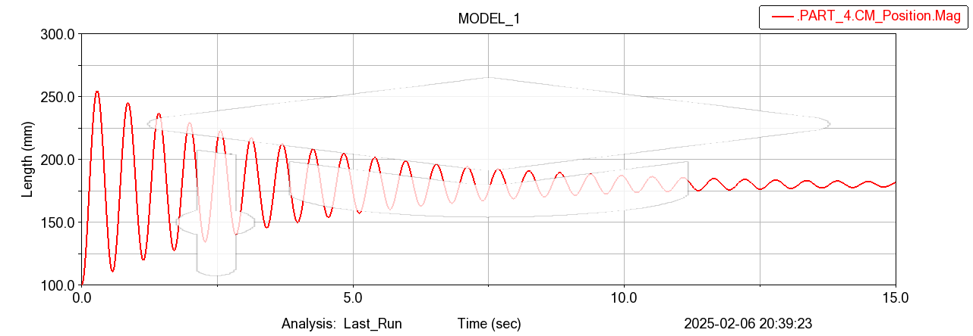

**Velocity**

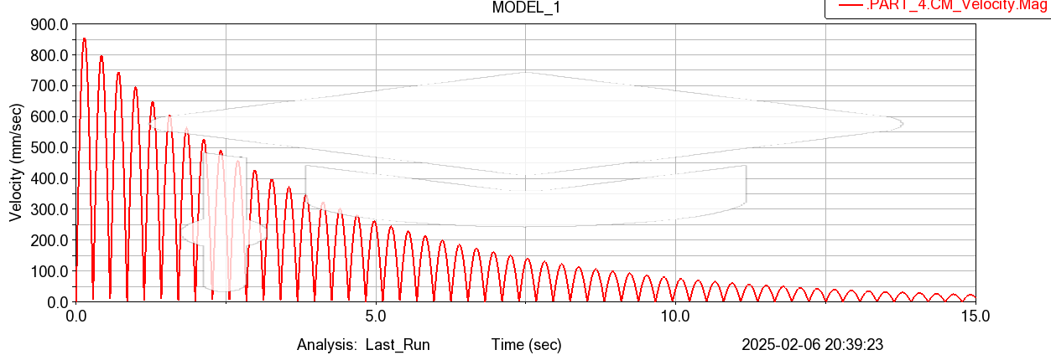

**Acceleration**

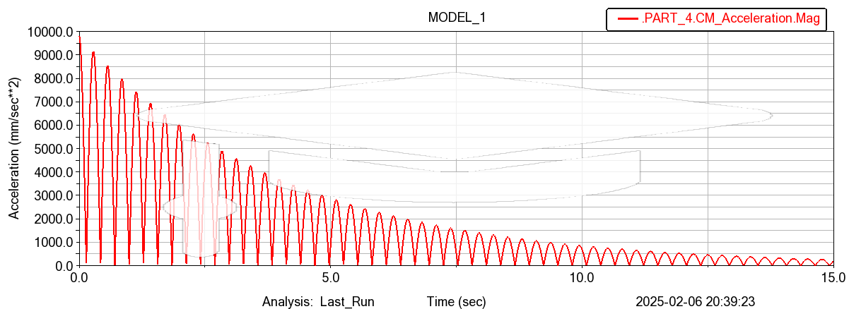

Kinematic analysis deals with the study of motion without considering the forces that cause the motion. In this analysis, the goal is to find out:

* The position, velocity, and acceleration of the mass.
* The motion of the spring and damper elements with respect to time.

Using MCS Addams, you can input the initial conditions (such as initial velocity and displacement) and simulate the movement of the mass as it oscillates or moves due to the spring and damping forces. By performing kinematic analysis, you can visualize the displacement, velocity, and acceleration at any given time.

**5. Dynamics Analysis**

Dynamic analysis focuses on the forces and moments that produce motion, considering the mass, damping, and spring constants.

* The equation of motion is generally represented as:  
  mx¨+cx˙+kx=F(t)m \ddot{x} + c \dot{x} + k x = F(t) Where:
  + mm is the mass
  + x¨\ddot{x} is the acceleration
  + x˙\dot{x} is the velocity
  + kk is the spring constant
  + cc is the damping coefficient
  + F(t)F(t) is the external force (if any)

In MCS Addams, dynamic analysis would allow you to simulate how the system behaves over time, analyzing how the spring constant and damping coefficient affect the motion.

**6. Plots of Velocity and Acceleration of Desired Points**

To understand how the system behaves under different conditions, it’s useful to plot the velocity and acceleration of the mass over time. This can be done within MCS Addams by selecting specific points (such as the center of mass of the body) and generating plots of the velocity and acceleration.

* **Velocity vs. Time**: Helps understand how fast the mass is moving at any given moment.
* **Acceleration vs. Time**: Shows how quickly the velocity is changing and can help identify moments of maximum or minimum acceleration.

**7. Interpretation**

The interpretation of the results involves analyzing the system’s behavior. Key points to look for include:

* **Damped Oscillations**: If the system is underdamped, it will oscillate with gradually decreasing amplitude. Overdamped systems will slowly approach equilibrium without oscillating.
* **Effect of Spring and Damping Constants**: How different values of the spring constant kk and damping coefficient cc affect the oscillations. For example, increasing damping reduces oscillations, while increasing the spring constant increases the system's stiffness.
* **Resonance**: Check if the system reaches resonance, which is the point where the system’s natural frequency matches the frequency of external forces, leading to large oscillations.

**8. Conclusion**

The conclusion summarizes the results and findings of the project:

* Discuss the behavior of the spring-damping system based on different configurations (spring constant, damping factor, etc.).
* Summarize the impact of key parameters like damping ratio and spring constant on the system's response (whether it’s underdamped, critically damped, or overdamped).
* Consider possible optimizations to achieve a desired system response (e.g., reducing vibrations, improving energy dissipation).

**9. Areas of Applications**

Spring-damping systems are widely used in many fields. Some key applications include:

* **Vehicle Suspensions**: To reduce vibrations and provide a smooth ride by absorbing road shocks.
* **Vibration Isolation**: In sensitive equipment like computers, medical instruments, and precision machinery.
* **Structural Engineering**: To dampen oscillations in buildings and bridges caused by wind or seismic activity.
* **Robotics**: In robotic arms or legs to absorb shocks and allow for smooth movements.
* **Sports Equipment**: Such as in shock-absorbing shoes or bike suspensions to improve comfort and performance.